Robotic Arm

Sheeza Waheed F2019376032

# Final Documentation

## CODE:

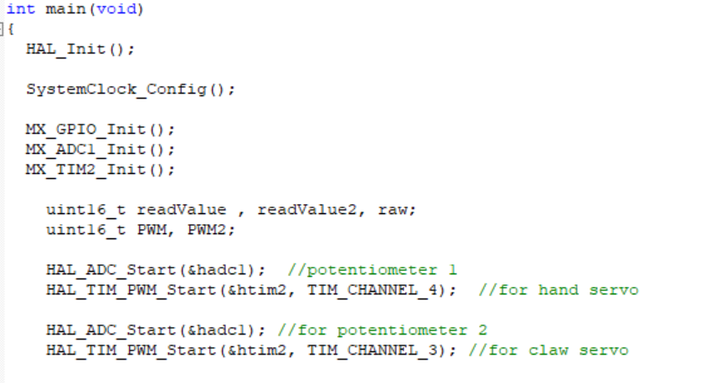

* 3 variables in row 1, stores the value of analogue pins i.e. the values of potentiometers
* 2 variables in row 2, stores the value of how much PWM to generate. Formula for which we will see shortly.
* PWM_Start function to generate PWM on the respective channels
* ADC_Start to start ADC

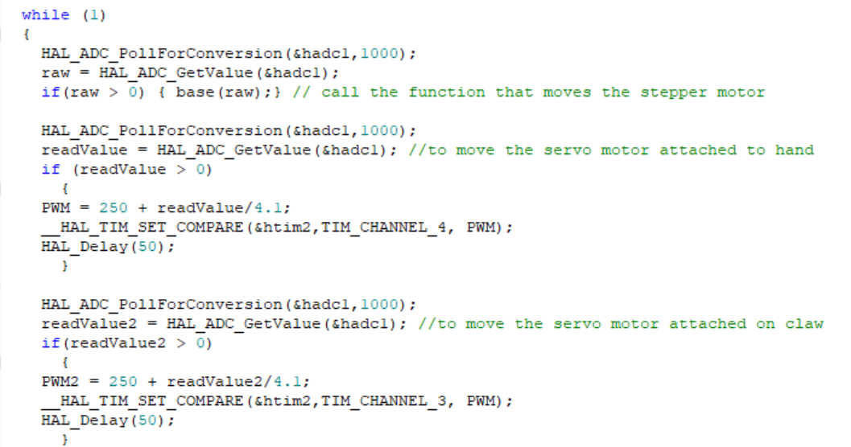

* Poll for conversion and when the conversion is completed we use the GetValue() function to get the value of ADC from potetiometer1 and store the value in a variable called “raw”
* If the value of raw is greater than 0 which means that the knob was moved, we call the base function that rotates the stepper motor
* 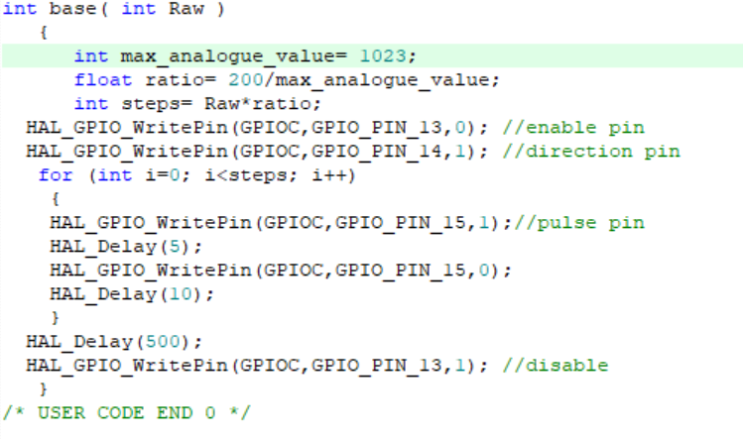
* Using the map function, I found out that the max value is 1023 so I stored the value in a variable
* By dividing the max value to the total number of steps and then multiplying it with the ADC value “raw” I got “number of steps to move”
* Then just a general code to move the motor to that many steps
* Next, how calculated the PWM value. It is same for both the servo motors so I’ll explain it one time.

# PWM = 250 + readValue2/4.1;

Frequency = 8000000/16 = 500000Hz (8Mhz is computer clock and 16 is pre-scalor /16 by default)

If I divide again by Counter period 10000 (set in CubeMX)

Frequency = 500000/10000 = 50Hz

The full pulse with time is = 1/50 seconds = 20 milli seconds

For the servo motor, I need to change the pulse from 0.5 ms to 2.5ms

(degree of rotation 0 to 180=> 0.5=0 $°$ 1.5=90 $°$, 2.5=180 $°$)

Full 100% pulse is 10000 according to counter period 10000

0 → 0

20 milli seconds → 10000

So, 0.5 milli seconds → 250

and 2.5 milli seconds → 1250

Now I can set __HAL_TIM_SET_COMPARE () from 250 to 1250

But the readValue from ADC is from 0 to 4095 (4095 is the max ADC value of servo)

How to map 0 to 4095 => 250 to 1250?

The method I used to map is:

If I divide readValue by 4.1, I will get approximately 0 to 1000

After that I add 250 to get 250 to 1250

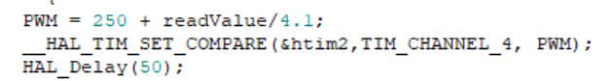

## CUBEMAX:

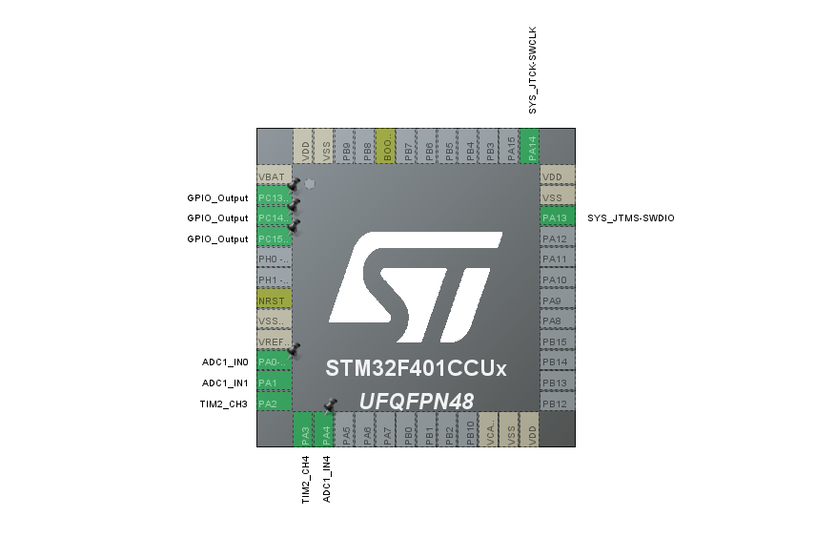

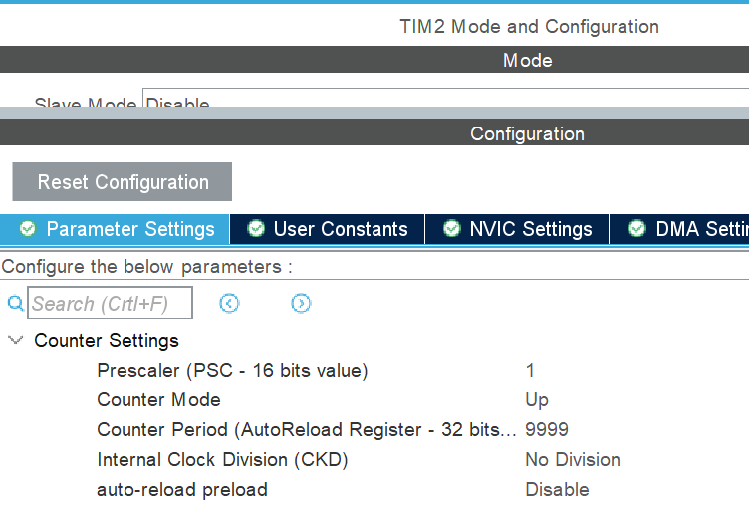

# Design:

Went through a lot of changes till the end because initially the design was beautiful and well-constructed but I learned from it that the arm was longer than its base which made it heavier to lift. For the video I had to eventually use a bigger servo but it used the same code and 5V for power.

In the final design I added a servo in the middle which pulled a wire (connected to the claw) left to right to eventually move one of the claws left to right as to “open and close”. However, that idea wasn’t that efficient so I set a servo directly under one of the claws fixing other claw still. That was efficient.

The major problem I faced was fixing the top servo and moving the arm. If I could change the whole design I would keep the arm smaller or use a different material altogether. Well this took a lot of trial and error testing.

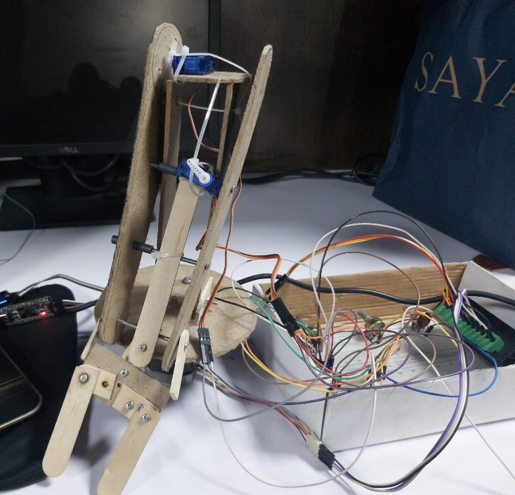Initial design: Final design:

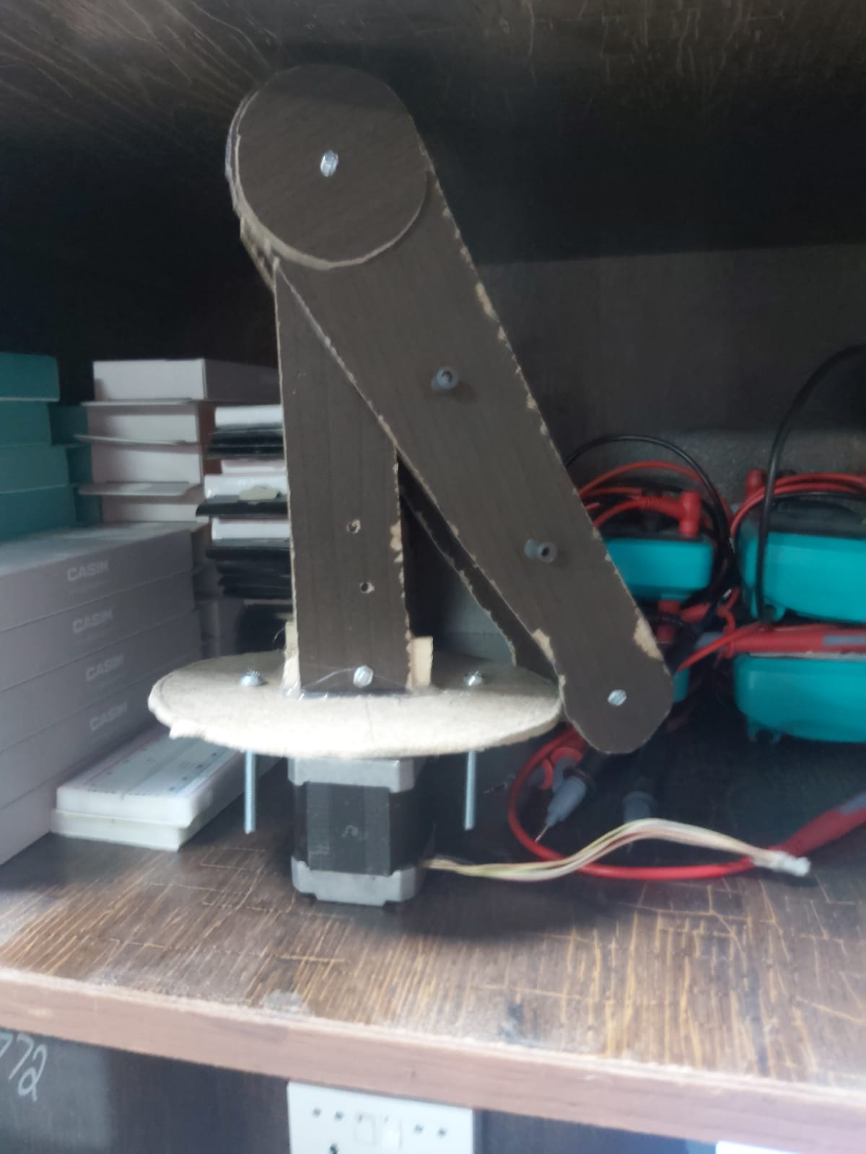

Screws that connected both the wooden slates. So, if one hand moves using one servo the other moves automatically

A circular disk in the middle to support the weight of the servo so when it rotates it rotates the hand and not itself

Had to add a smaller wooden stick so we could attach a plate with claws. This was to lighten the weight of the wood on the sides and to lessen the burden for the servo behind